CONNECTED, LEVEL 4 2014, What’s the Evidence?  Beating the Wind  by Bronwen Wall  Overview  In this article, scientist Lindsey Underwood explains to fictional character “Zephyr” how aerodynamics can improve the performance of racing cyclists. The article demonstrates the use of evidence to find ways to reduce aerodynamic drag.  A Google Slides version of this article is available at www.connected.tki.org.nz. |  |  | 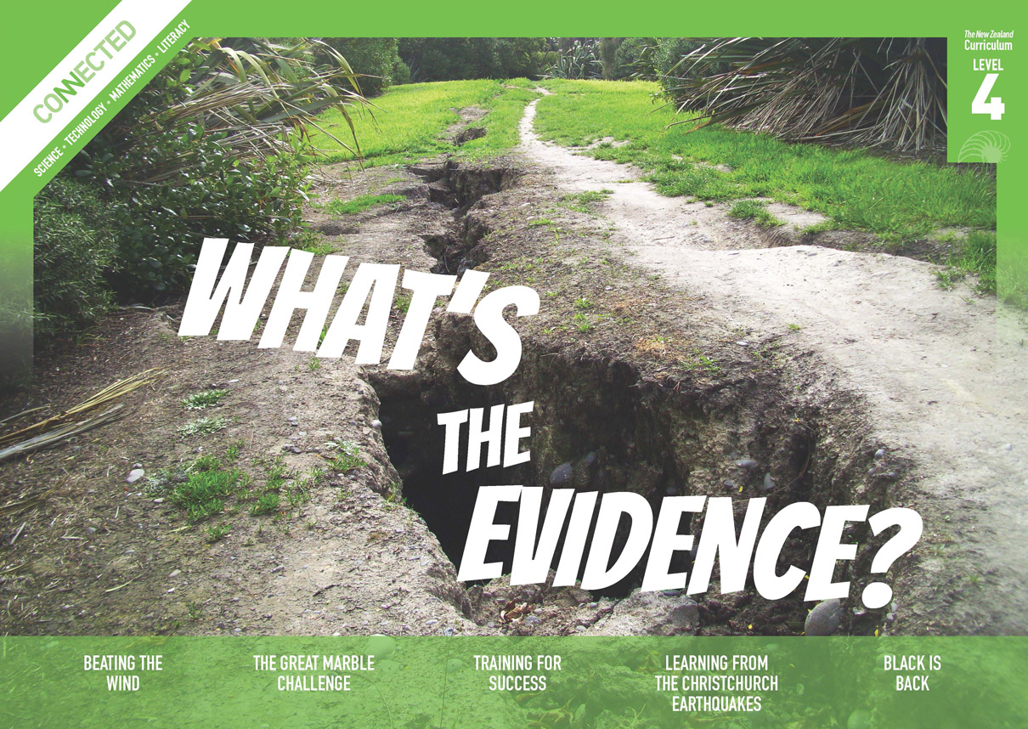  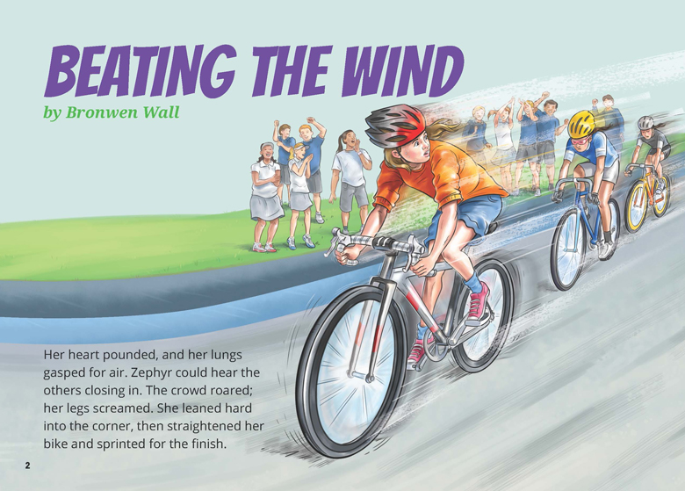
Science capability: Use evidence |  | Text characteristics

Science is a way of explaining the world. Science is empirical and measurable. This means that in science, explanations need to be supported by evidence that is based on, or derived from, observations of the natural world. Students should be encouraged to support their ideas with evidence and look for evidence that supports or contradicts other explanations.  At the core of science is theory building – making better explanations. What sets scientific explanations apart from other ways of explaining the world is their reliance on evidence and their ability to evolve as new evidence comes to light.  For more information about the “Use evidence” science capability, go to http://scienceonline.tki.org.nz/Introducing-five-science-capabilities/Use-evidence |  | - A mixed text type that combines a recount, report, and explanation.  - Subheadings, illustrations, text boxes, and diagrams containing main ideas that relate to the content.  - Scientific vocabulary and terminology.

Curriculum context

SCIENCE
NATURE OF SCIENCE: Understanding about science  Achievement objective(s)  L4: Students will identify ways in which scientists work together and provide evidence to support their ideas.  NATURE OF SCIENCE: Investigating in science  Achievement objective(s)  L4: Students will ask questions, find evidence, explore simple models, and carry out appropriate investigations to develop simple explanations. |  | PHYSICAL WORLD: Physical inquiry and physics concepts  Achievement objective(s)  L4: Students will explore, describe, and represent patterns and trends for everyday examples of physical phenomena, such as movement, forces … For example, identify and describe the effect of forces (contact and non-contact) on the motion of objects; identify and describe everyday examples of sources of energy, forms of energy, and energy transformations. |  | Key Nature of Science ideas  - Evidence is based on, or derived from, observations of the natural world.  - Scientific ideas and explanations are supported by evidence.  - Scientists make use of relevant evidence to support or revise their predictions and explanations.  Key science ideas  - We cannot see forces, but we can see their effects, for example, change in motion.  - Forces make objects move or change their movement. As this happens, energy changes occur.  - Friction is a force that makes it harder to move things or slow things down.

ENGLISH

READING  Ideas  Students will show an increasing understanding of ideas within, across, and beyond texts. |  | INDICATORS  - Makes meaning of increasingly complex texts by identifying and understanding main and subsidiary ideas and the links between them.  - Makes connections by thinking about underlying ideas within and between texts from a range of contexts.  - Recognises that there may be more than one reading available within a text.  - Makes and supports inferences from texts with increasing independence. |  | THE LITERACY LEARNING PROGRESSIONS  The literacy knowledge and skills that students need to draw on by the end of year 8 are described in The Literacy Learning Progressions.

Using evidence

- Scientists use empirical evidence to develop theories about how the world works.
- Empirical evidence is data gathered from observations and experiments.
The science capability, Use evidence, is about students developing and considering theories and explanations in the light of evidence (http://scienceonline.tki.org.nz/Introducing-five-science-capabilities/Use-evidence).
Students should be:
- using evidence they have gathered to develop their own explanations about the way the world works
- critiquing explanations offered by others, including scientifically accepted explanations, by considering the evidence that supports them.
Scientific explanations, including those found in museums, in television programmes, on the Internet, and in non-fiction books and texts, often fail to discuss the evidence and testing that led to the development of these explanations.
Teachers can:
- help students to be more critical consumers of science information by being explicitly critical themselves
- model a sceptical stance
- ask questions such as:
  - How do you think people found that out about that?
  - What kind of evidence would support that idea?
  - How could a scientist test that idea?
- use concept cartoons to propose possible explanations. (See http://conceptcartoons.com/what-is-a-concept-cartoon-.html)
When doing practical investigations, teachers can support students to:
- consider a range of possible explanations for their findings
- think about how these explanations fit with the evidence they have gathered
- avoid suggesting that scientific investigations prove anything – rather, investigations provide evidence that supports or refutes a hypothesis or idea.
Establish a science classroom culture by:
- welcoming a range of possible explanations
- encouraging students to consider possible explanations in the light of evidence
- having students draw evidence from their experience
- using questions such as:
  - What have we seen today that supports X’s idea?
  - Has anyone seen anything somewhere else that might be evidence for X’s idea?
- encouraging investigation:
  - What could we do to test X’s idea?
  - What would we expect to happen? Why?
A range of questions and activities designed to get students to use evidence is available on the Science Online website: http://scienceonline.tki.org.nz/Introducing-five-science-capabilities/Use-evidence

Meeting the literacy challenges

The following instructional strategies will support students to understand, respond to, and think critically about the information and ideas in the text. After reading the text, support students to explore the key science ideas outlined in the following pages.

TEACHER resources

Want to know more about instructional strategies? Go to:
- http://literacyonline.tki.org.nz/Literacy-Online/Teacher-needs/Reviewed-resources/Reading/Comprehension/ELP-years-5-8
- “Engaging Learners with Texts” (Chapter 5) from Effective Literacy Practice in Years 1 to 4 (Ministry of Education, 2003).
Want to know more about what literacy skills and knowledge your students need? Go to:
- http://literacyonline.tki.org.nz/Literacy-Online/Student-needs/National-Standards-Reading-and-Writing
- www.literacyprogressions.tki.org.nz/
“Working with Comprehension Strategies” (Chapter 5) from Teaching Reading Comprehension (Davis, 2007) gives comprehensive guidance for explicit strategy instruction in years 4–8.
Teaching Reading Comprehension Strategies: A Practical Classroom Guide (Cameron, 2009) provides information, resources, and tools for comprehension strategy instruction.

INSTRUCTIONAL STRATEGIES

FINDING THE MAIN IDEAS
Read the first paragraph on page 2. ASK QUESTIONS to support the students to identify the main ideas.
What does the title suggest the article is about?
What descriptive words does the writer use to show you that Zephyr is desperate to win the race?
At the end of the paragraph, do you think Zephyr has won? Why or why not?
How did using the title help you to work out the main ideas?
Read the first section on page 3 and have the students SCAN the headings and illustrations in the rest of the article. ASK QUESTIONS to support them to predict what each part will be about.
Why did Zephyr lose the race?
What might the author mean by “What a Drag”? What is the double meaning here?
What are wind tunnels used for?
What evidence did Lindsey use to improve cyclists’ times?
What do you notice about the illustrations in the text box on page 6?
On page 7, one heading is “Smooth Operators” and the other is “What’s with the Dimples”? What is the difference between something that is smooth and something that has dimples? What might the message be?
How did scanning the headings and illustrations help you to predict what each part was about?

Check that the students understand that this article is about the impact of wind resistance on cycling. Looking at page 2, DISCUSS how Zephyr could have reduced friction to help her ride more quickly.
What information might Lindsey give Zephyr that would help her get that “extra edge”?
As you read, what text features helped you to find and track the main ideas?
MODEL how to use clues from the text to RECORD information using a graphic organiser like this.

What Zephyr found out | How it might help her

Have the students reread the text to IDENTIFY the different ways Lindsey “used evidence”.

USING DESIGN FEATURES FOR DEEPER UNDERSTANDING
PROMPT the students to look closely at the diagram on page 4 and connect it to the explanation in the text.
What is draughting?
What are the benefits of draughting?
Looking at the diagram, which of the cyclists are in the best positions? Which are in the worst positions? Why?
How did the diagram help you to gain a clearer picture of draughting and to understand how a peloton works?
PROMPT the students to compare the illustration of Lindsey and Zephyr on page 7 with the images of the golf balls.
What message do these images share?

DEALING WITH SCIENTIFIC VOCABULARY
Have the students IDENTIFY and LIST new vocabulary. Then have them SORT the vocabulary according to how they worked out the meanings. Categories could include:
I know this word from another context.
I found a clue to the meaning in the text.
I predicted this meaning from reading the text.
The word is in the glossary.
We use this word in technology.
I can see the meaning from the illustration.
I found the word in a dictionary.
I found the word in a thesaurus.
Create a classroom word bank that includes these words.
If the students haven’t noticed for themselves, PROMPT them to notice the play on words at the beginning of page 8: “Zephyr felt a light wind brush her cheek”. (“Zephyr” means “a light wind or west wind”.)

Teacher support
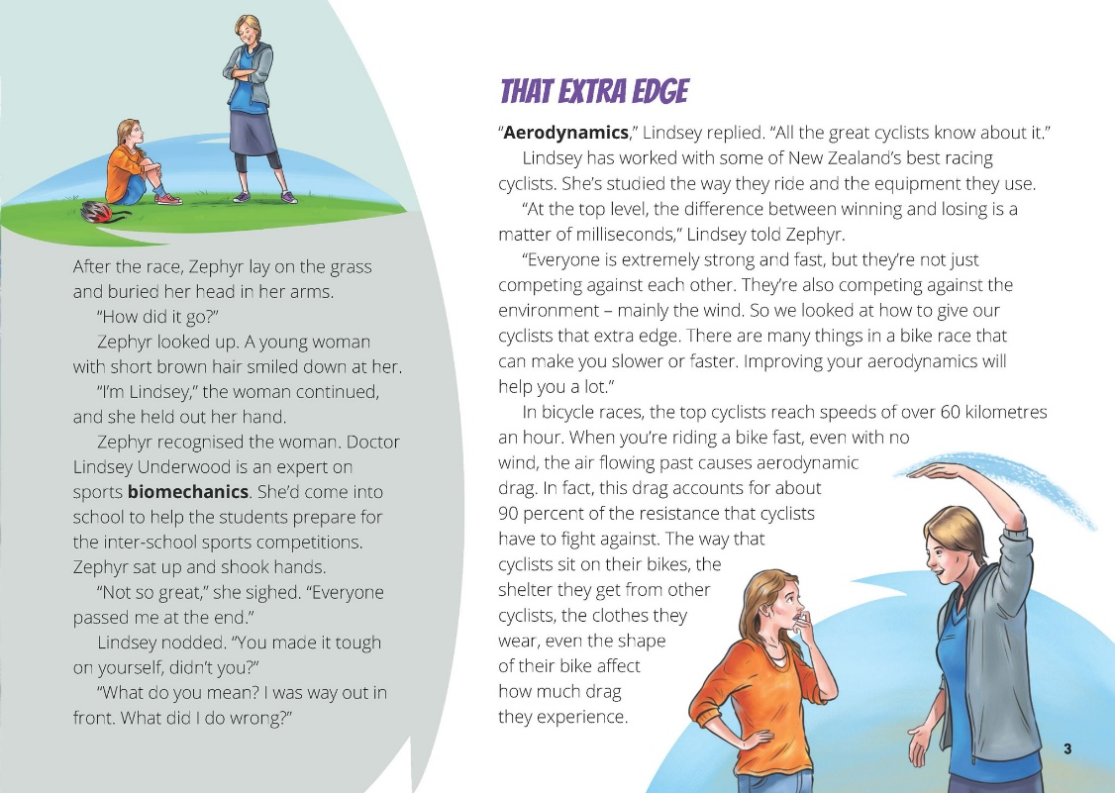 | Asking questions can lead to investigations to develop explanations.  Scientists and cyclists work together to gather evidence to support ideas.  Friction is a force that makes it harder to move things or slow moving things down.
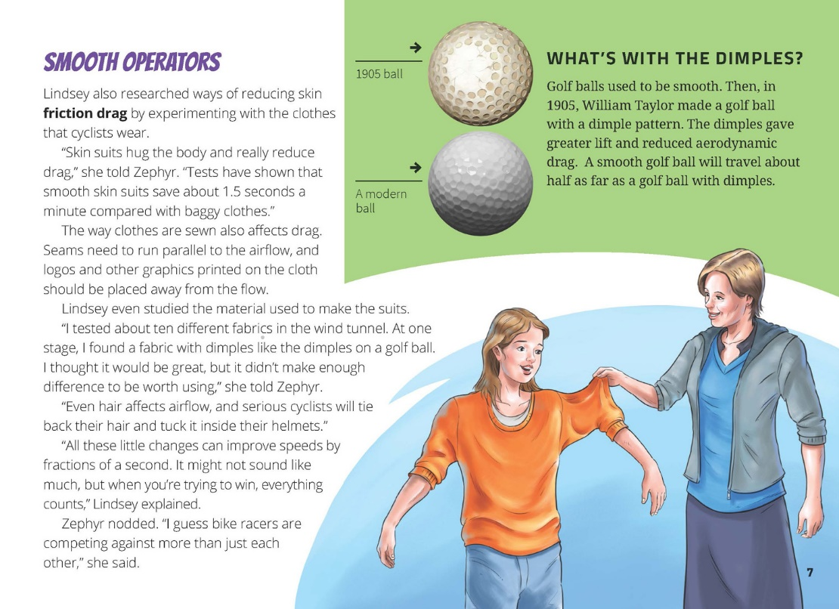 | We cannot see forces, but we can see their effects.  Scientists use evidence to support or revise their predictions and explanations.  Evidence is based on observations of the natural world.

Exploring the science
Some activities focus directly on the science capability of “using evidence to support ideas” and the Nature of Science strand. Other activities extend student content knowledge. You are encouraged to adapt these activities to make the focus on Nature of Science explicit and to support students to develop the capability of using evidence to support ideas.

LEARNING FOCUS
Scientists use evidence from observations to support ideas.

LEARNING ACTIVITIES

First, it could be useful to help students think about what air is and why it can push (air resistance). Students often think that air is nothing because they cannot see it, so a first step could be to explore the nature of air in a practical way. Make connections with students’ everyday experiences of feeling air push, such as walking in the wind, running fast, or feeling a rush of air as a fast car or big truck passes them. Activities about air and air resistance can be found in The Air around Us, Building Science Concepts book 30.

Activity 1: Cycling aerodynamics
Find out more about aerodynamics and how competitive cyclists use it. The Science Learning Hub context “Cycling Aerodynamics” (www.sciencelearn.org.nz/Science-Stories/Cycling-Aerodynamics/Lindsey-Underwood) allows students to learn more about how Lindsey Underwood and her colleague Dr Mark Jermy work with cyclists and coaches to help find the body position and equipment that works best for them.
If your students are not cyclists, provide a bicycle for them to observe. Help them to create a diagram of a bicycle, as described in Section One of Bikes: Levers, Friction, and Motion, Building Science Concepts book 59.
Have the students write a list of questions that they would like to ask Lindsey Underwood about aerodynamics. Put the questions on a chart, leaving room to record the answers and to add more questions. Keep the chart on display to provide a purpose for learning. Read the profile of Lindsey Alton (née Underwood) on the Science Learning Hub (www.sciencelearn.org.nz/Science-Stories/Cycling-Aerodynamics/Lindsey-Underwood) before seeking answers to the questions.
The Science Learning Hub article “Wind Tunnel Testing of Cyclists” (www.sciencelearn.org.nz/Science-Stories/Cycling-Aerodynamics/Sci-Media/Video/The-wind-tunnel) describes how Mark and Lindsey are using the University of Canterbury wind tunnel to analyse airflow and drag as high-speed wind moves over cyclists. It includes two videos where they explain the use of the wind tunnel and how they go about testing the aerodynamics of elite cyclists. View the videos and use your chart to record any answers to the students’ questions.
Did this answer all your questions?
Do you have any other questions you would like to ask?
After conducting each of the following activities, return to the chart to record your answers and add any more questions. Select further activities that will help answer the students’ questions. All these activities are described in detail on the Science Learning Hub.
Create a wind tunnel using a hairdryer or fan and use this to test different shapes for resistance, as described in the activity “Investigating airflow over shapes” (www.sciencelearn.org.nz/Science-Stories/Cycling-Aerodynamics/Investigating-airflow-over-shapes).
“On Your Bikes” (www.sciencelearn.org.nz/Science-Stories/Cycling-Aerodynamics/On-your-bikes) is an activity in which students measure speed and drag to determine the effects of aerodynamic drag and rolling resistance on a cyclist’s maximum speed. The students watch the video clips “Aerodynamics and Drag” and “What is Rolling Resistance?” before conducting an experiment in which they time a cyclist’s speed to find out how aerodynamic drag and rolling resistance affect maximum speed. You could do follow-up activities to allow the students to go deeper into these concepts. These are good activities for supporting learning about how to represent and interpret data. It would be helpful to explore concepts such as speed (velocity) and force in practical ways before students attempt these activities. Practical explorations of these concepts are in the Building Science Concepts books 42 and 59 (see below).
“Individual Pursuit Graphs” (www.sciencelearn.org.nz/Science-Stories/Cycling-Aerodynamics/Individual-pursuit-graphs) has students analyse graphs that show speed, force, and power for Alison Shanks (one of New Zealand’s world champion cyclists) in the women’s 3000-metre individual pursuit. By the end of this activity, students should be able to:
describe motion based on information from a speed versus time graph
use a graph to estimate acceleration and distance travelled
use graphs of speed and force to estimate aerodynamic drag.
You could also use the activities in Building Science Concepts books 42 and 59 to explore concepts about forces and friction. Students investigate forces and how they act. They look at how some parts of a bicycle are designed to reduce friction while other parts are designed to increase friction, making the bicycle safer. Conclude by having the students use the information on their charts to write an alternative ending for this article.
How do you think Zephyr used this information?
The writer implies that Zephyr is thinking about what she has learned, but will it help her to win?
Extension
View the TVNZ item on the new velodrome in Cambridge (http://tvnz.co.nz/othersports-news/stunning-cambridge-cycling-velodrome-takes-shape-video-5718201). Students could research the technology of the track.
What features of the velodrome’s design make it a “fast track”?
Has the velodrome met people’s expectations? Why or why not?

Activity 2: Putting drag resistance to use
Explain that engineers use an understanding of drag resistance when they design planes, parachutes, and ships.
Given what you know, how might drag resistance work?
Discuss what a parachute is and how it works before investigating the question “Does the size of a parachute affect the dropping speed?” Have the students create a hypothesis: “Based on this article, what would you expect to happen?”
Have the students use paper, tape, and string to design a simple parachute that they can take outside and observe for the speed of descent and the safety of the landing. To ensure a fair test, they will need to keep all the variables the same each time they do the test, varying only the size of their parachute. Afterwards, have the students use their evidence to explain what happened. Did the evidence support their hypothesis?
The “Design a Parachute” activity from Teach Engineering (www.teachengineering.org/view_activity.php?url= collection/wpi_/activities/wpi_design_a_parachute/design_a_parachute.xml) provides some ideas for this activity.

Activity 3: Exploring gears and levers
Section 3 of Bikes: Levers, Friction, and Motion, Building Science Concepts book 59, has activities for learning about the levers on a bicycle and how different levers are used to reduce effort and to steer. Connect this learning to the three activities in the “Force and Motion” section of Making Better Sense of the Physical World that explain how gears work: “Activity 6: Wheels with Teeth”, “Activity 7: Going a Different Way”, and “Investigation 3: Bicycle Science”.
Google Slides version of “Beating the Wind” www.connected.tki.org.nz

RESOURCE LINKS

Building Science Concepts
Book 30 – The Air around Us
Book 42 – Marbles: Exploring Motion and Forces
Book 59 – Bikes: Levers, Friction, and Motion
Making Better Sense of the Physical World: Force and Motion
“Activity 6: Wheels with Teeth”, p 114.
“Activity 7: Going a Different Way”, p 114.
“Investigation 3: Bicycle Science”, p 115.
Science Learning Hub
“Aerodynamics and drag” at www.sciencelearn.org.nz/Science-Stories/Cycling-Aerodynamics/Sci-Media/Video/Aerodynamics-and-drag
“Cycling Aerodynamics” at www.sciencelearn.org.nz/Science-Stories/Cycling-Aerodynamics
“Individual Pursuit Graphs” at www.sciencelearn.org.nz/Science-Stories/Cycling-Aerodynamics/Individual-pursuit-graphs
“Investigating Airflow over Shapes” at www.sciencelearn.org.nz/Science-Stories/Cycling-Aerodynamics/Investigating-airflow-over-shapes
“Lindsey Underwood” at www.sciencelearn.org.nz/Science-Stories/Cycling-Aerodynamics/Lindsey-Underwood
“On Your Bikes” at www.sciencelearn.org.nz/Science-Stories/Cycling-Aerodynamics/On-your-bikes
“The Wind Tunnel” at www.sciencelearn.org.nz/Science-Stories/Cycling-Aerodynamics/Sci-Media/Video/The-wind-tunnel
“What Is Rolling Resistance?” at www.sciencelearn.org.nz/Science-Stories/Cycling-Aerodynamics/Sci-Media/Video/What-is-rolling-resistance
“Wind Tunnel Testing of Cyclists” at www.sciencelearn.org.nz/Science-Stories/Cycling-Aerodynamics/Wind-tunnel-testing-of-cyclists
Other Resources
“Hands-on Activity: Design a Parachute” from Teach Engineering, www.teachengineering.org/view_activity.php?url=collection/wpi_/activities/wpi_design_a_parachute/design_a_parachute.xml
“Stunning Cambridge Cycling Velodrome Takes Shape” from http://tvnz.co.nz/othersports-news/stunning-cambridge-cycling-velodrome-takes-shape-video-5718201
“The Big Race” Connected 2, 2006.
“Good Sport?” in Figure It Out: Technology Transformations (Levels 3+–4+)

